1 - GET/ https://modashopbackend-production.up.railway.app/products/
Lists all the products in the database
API Response
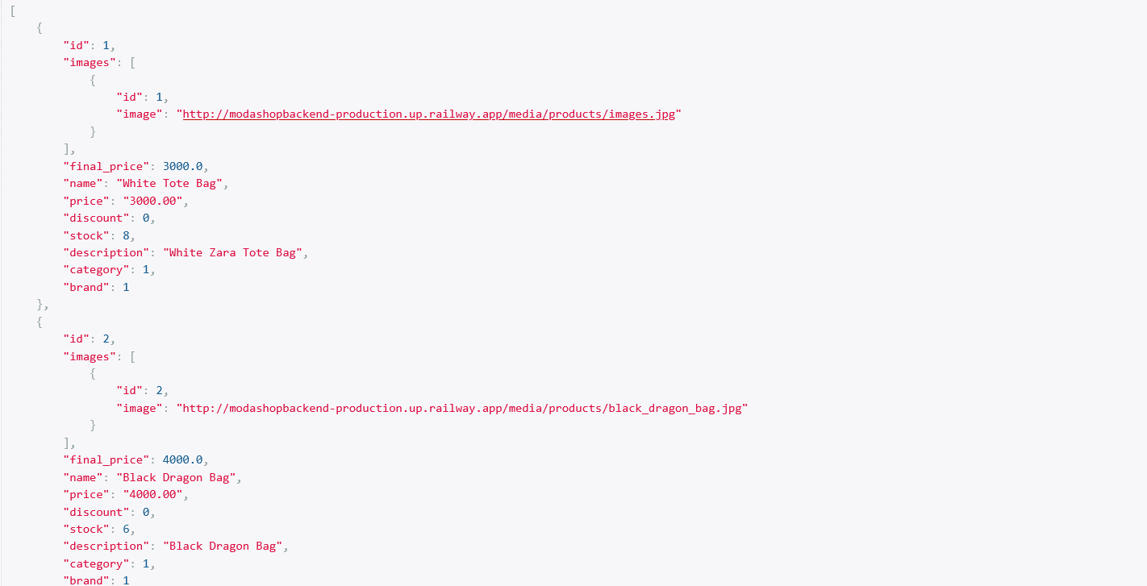

2 - GET/ https://modashopbackend-production.up.railway.app/products/<product_id>
Gets one product using its ID
API Response
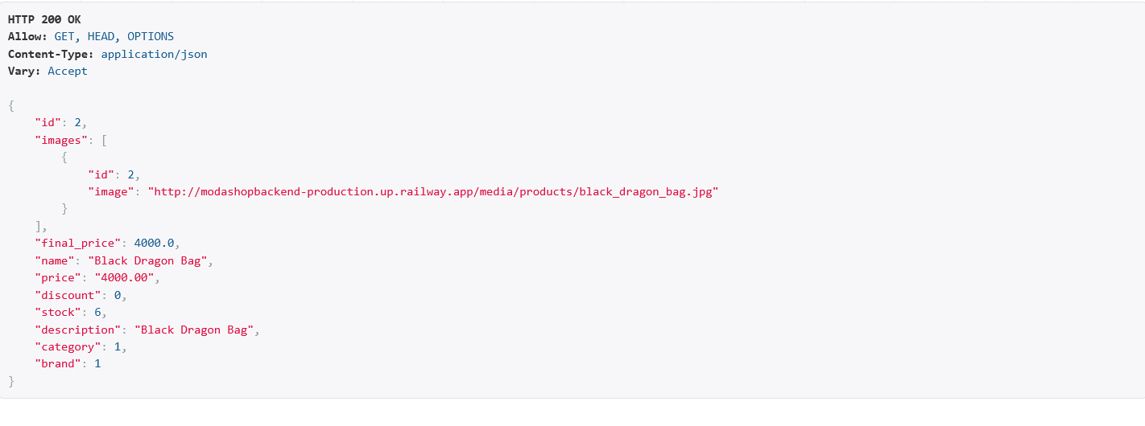

3 - GET/ https://modashopbackend-production.up.railway.app/api/cart/
Gets User Cart (Uses Authorization token to get the cart otherwise throws 401 Unauthorized)
API Response
Authorized:
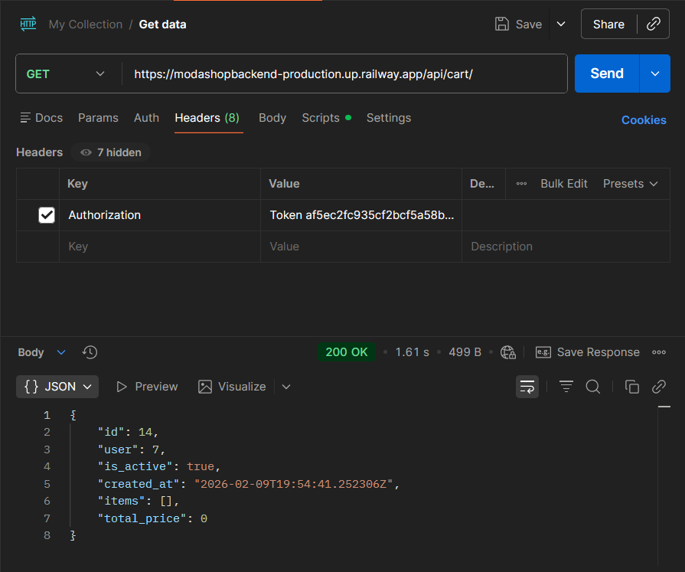
Unauthorized:
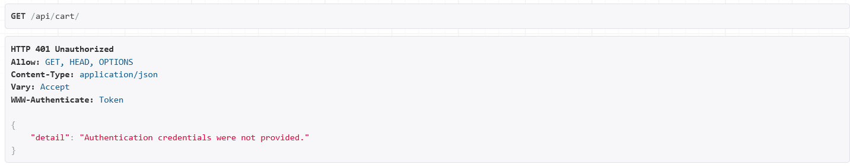
NOTE: ALL THE CART APIs, USER MUST BE AUTHENTICATED
4 - POST/ https://modashopbackend-production.up.railway.app/api/cart/add_item/
Adds items to user cart (item details must be posted in the same notation as the JSON appears)
API Response and Body in request
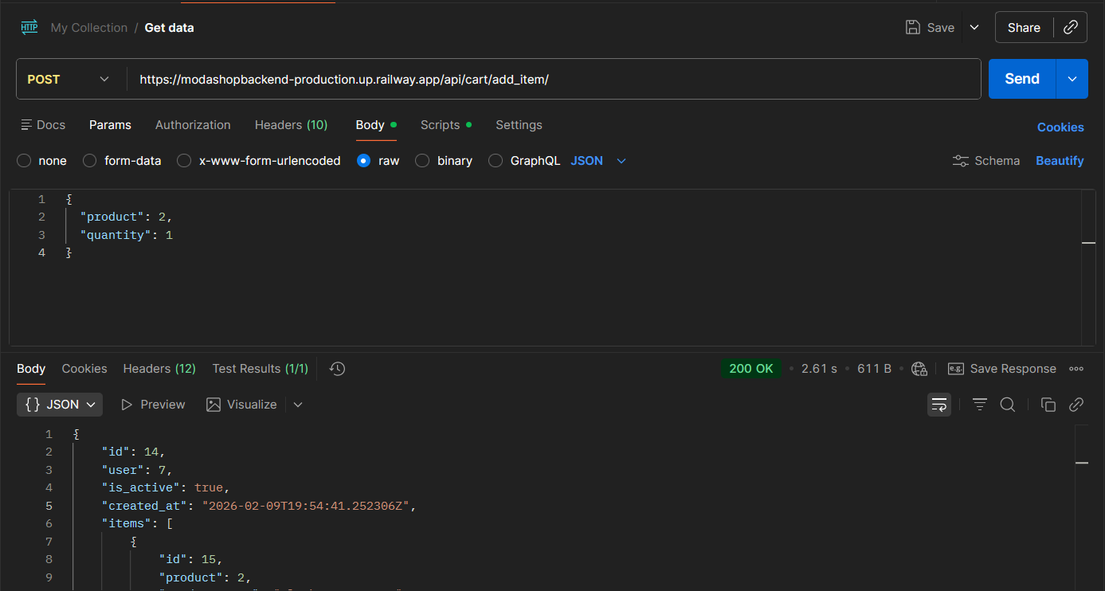

5 – POST/ https://modashopbackend-production.up.railway.app/api/cart/remove_item/
Removes items from user cart (item details must be posted in the same notation as the JSON appears)
API Response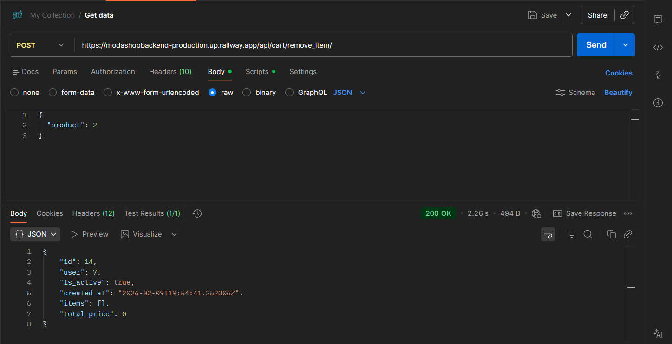
6 – POST/ https://modashopbackend-production.up.railway.app/api/cart/update_quantity/
Updates items quantity (item details must be posted in the same notation as the JSON appears, Items must be available in the cart)
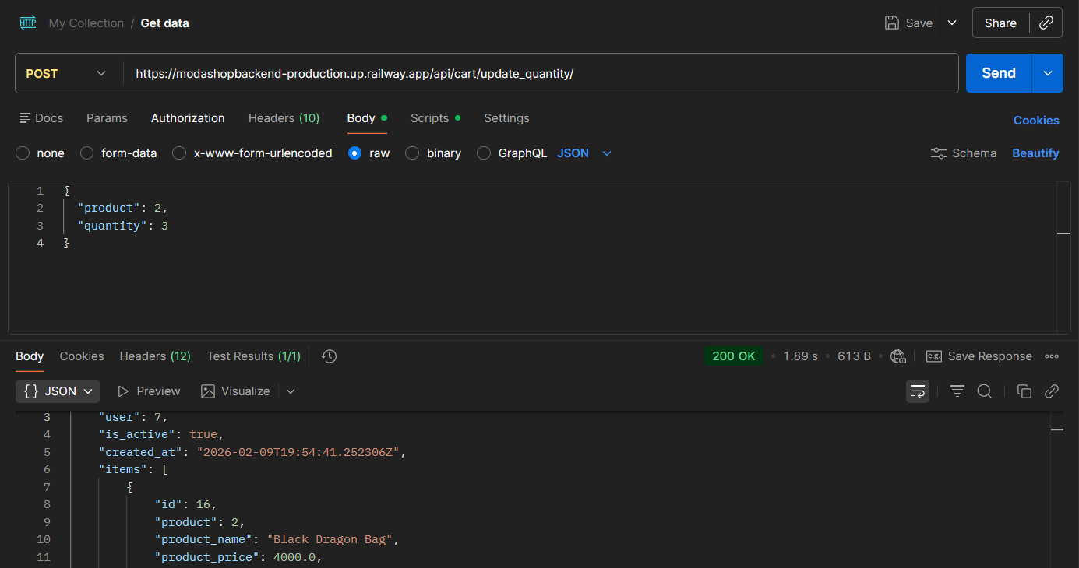
API Response

POST/ https://modashopbackend-production.up.railway.app/api/cart/apply_coupon/
Applies Coupon to the cart and returns the price after the coupon
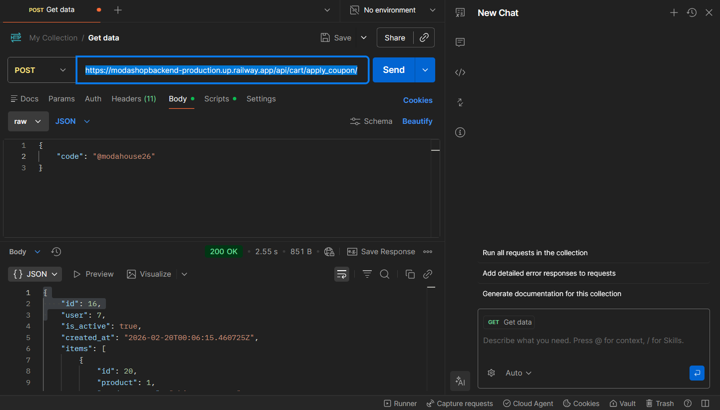

POST/ https://modashopbackend-production.up.railway.app/api/cart/remove_coupon/
Removes coupon from the cart 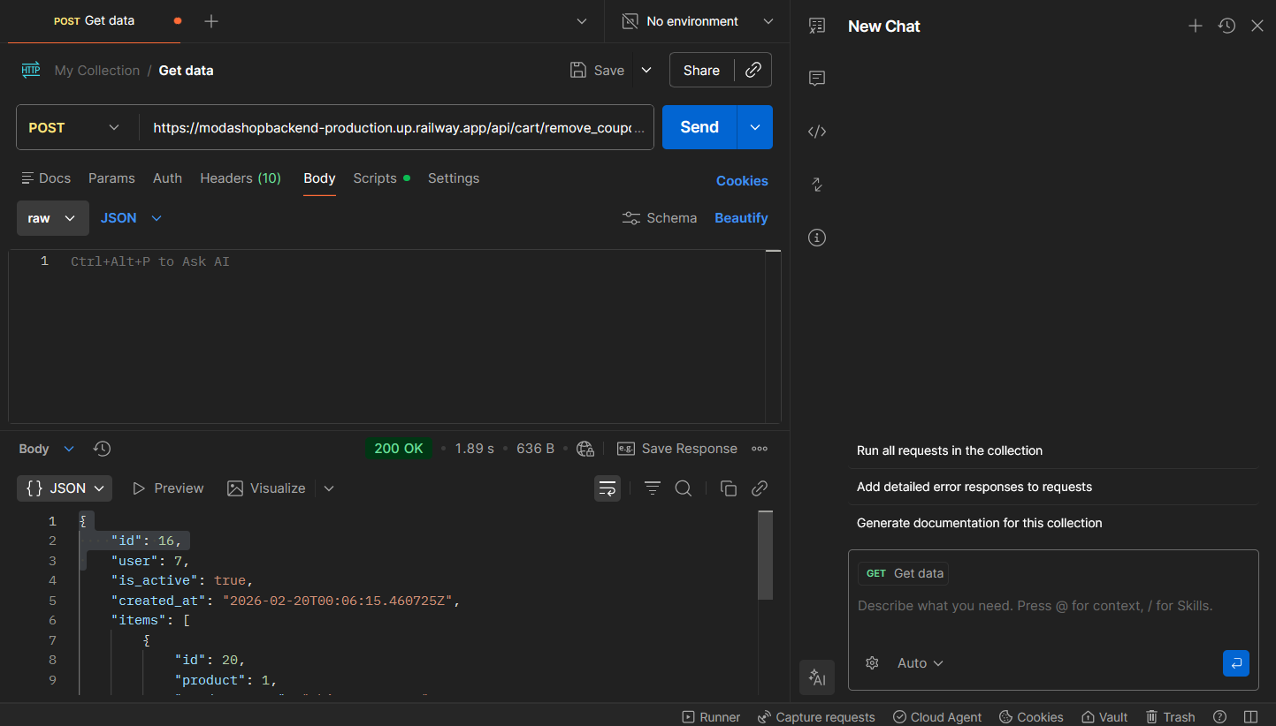

7 – POST/ https://modashopbackend-production.up.railway.app/api/cart/checkout/
Checks out the cart and order status are placed to be pending in the database (item details must be posted in the same notation as the JSON appears, Items must be available in the cart)
Edit: Now must send the payment method with the body* (cod or online)
*This API Might throw a connection error due to Railway free hosting restrictions
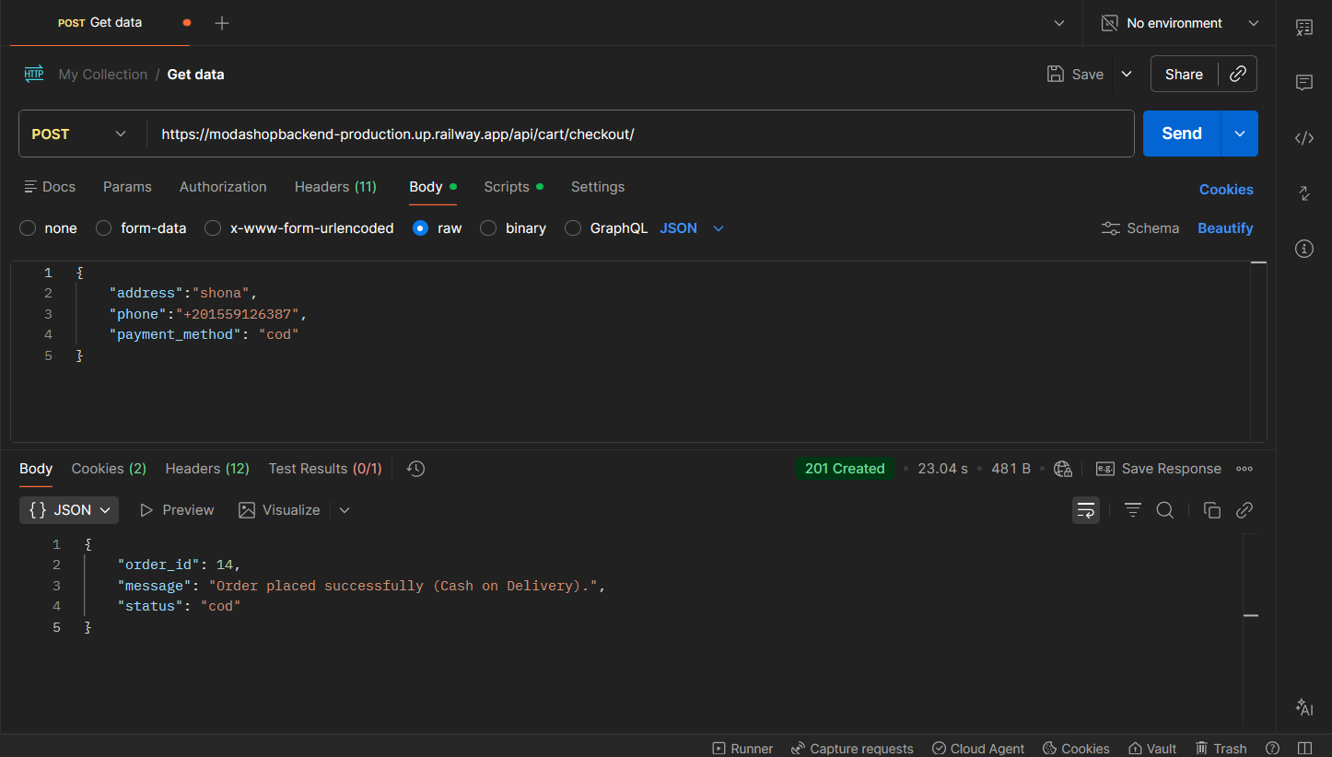
8 - POST/
https://modashopbackend-production.up.railway.app/api/payments/pay/<order_id>
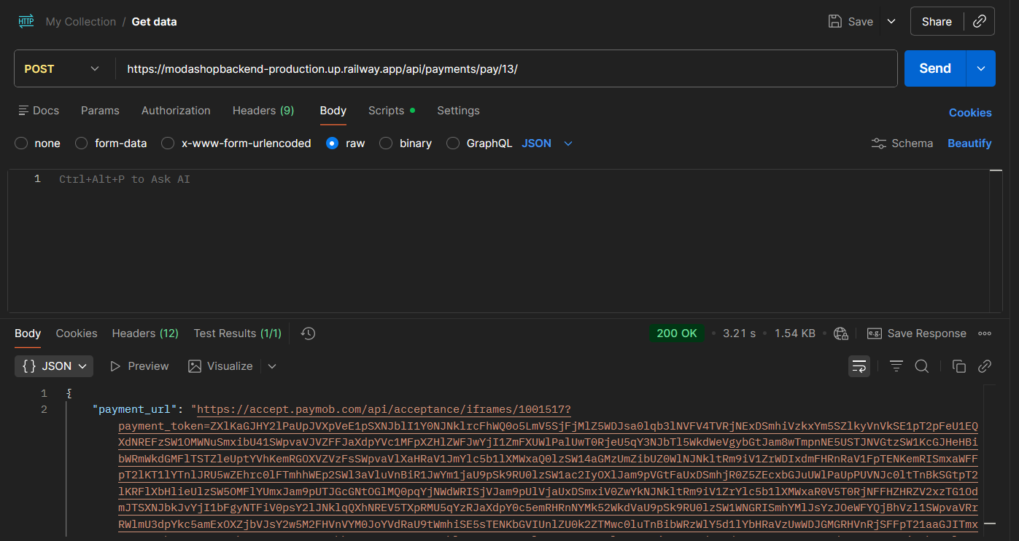
User Must be redirected to the link in the response of the API to begin the payment process

9 - POST/
https://modashopbackend-production.up.railway.app/orders/update_order/
Data must be send as follows:
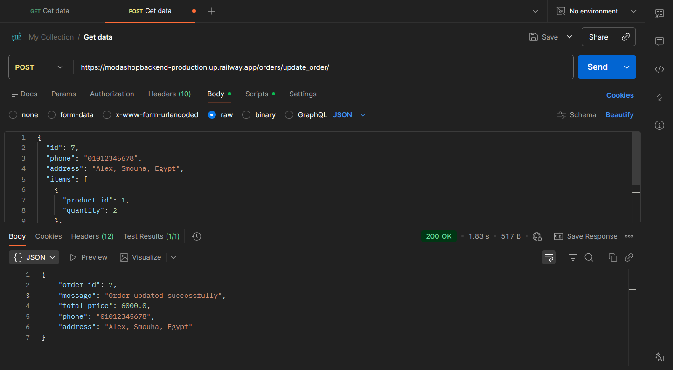
10 – GET / https://modashopbackend-production.up.railway.app/me/
Retrieves user name and email address and previous orders (requires Authentication)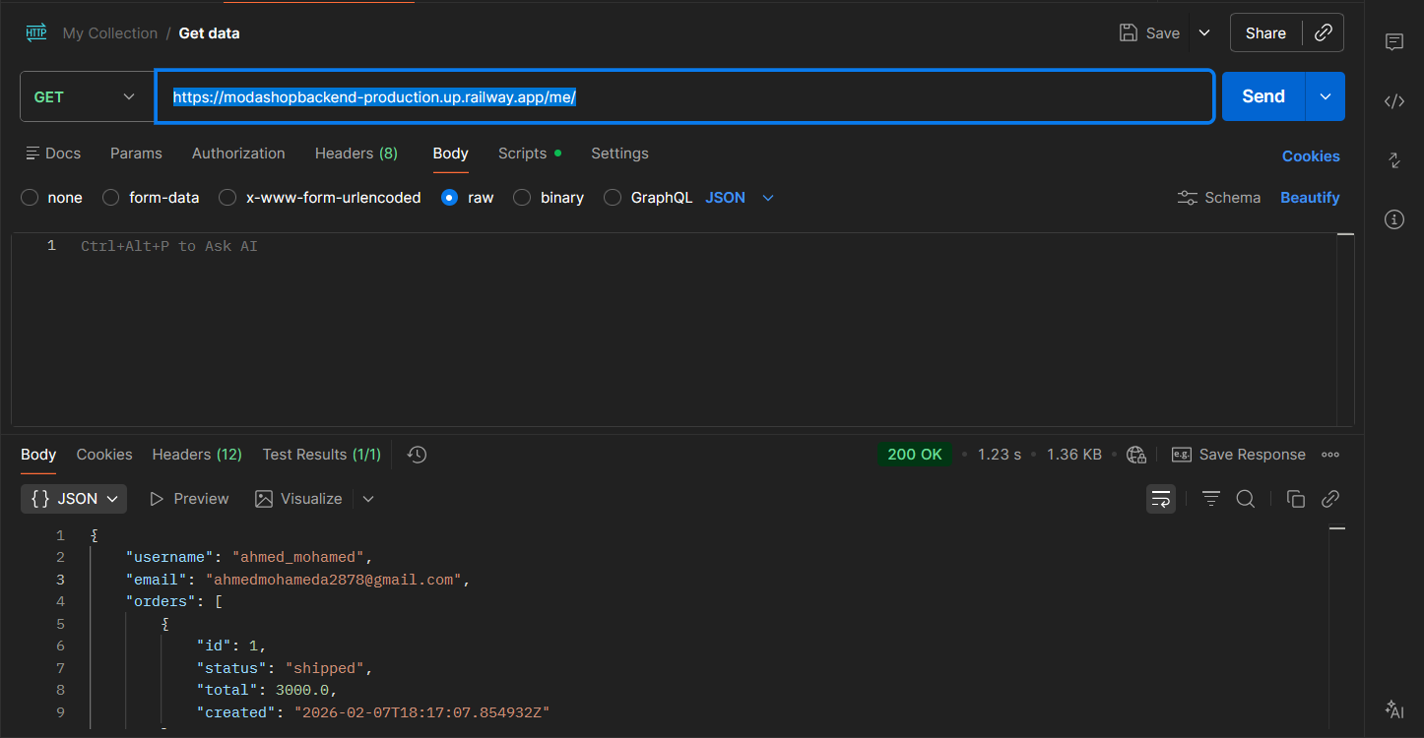
11 – POST/ https://modashopbackend-production.up.railway.app/api/auth/register/
Register a new user and must send data as follows:
*Might return an error with a code 500 because of Railway free restrictions
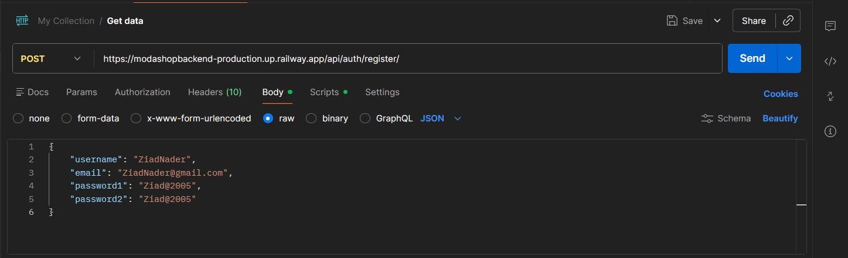

12 – POST/ https://modashopbackend-production.up.railway.app/api/auth/login/
Logs in an existing user with verified Email
Returns an Authentication Token.
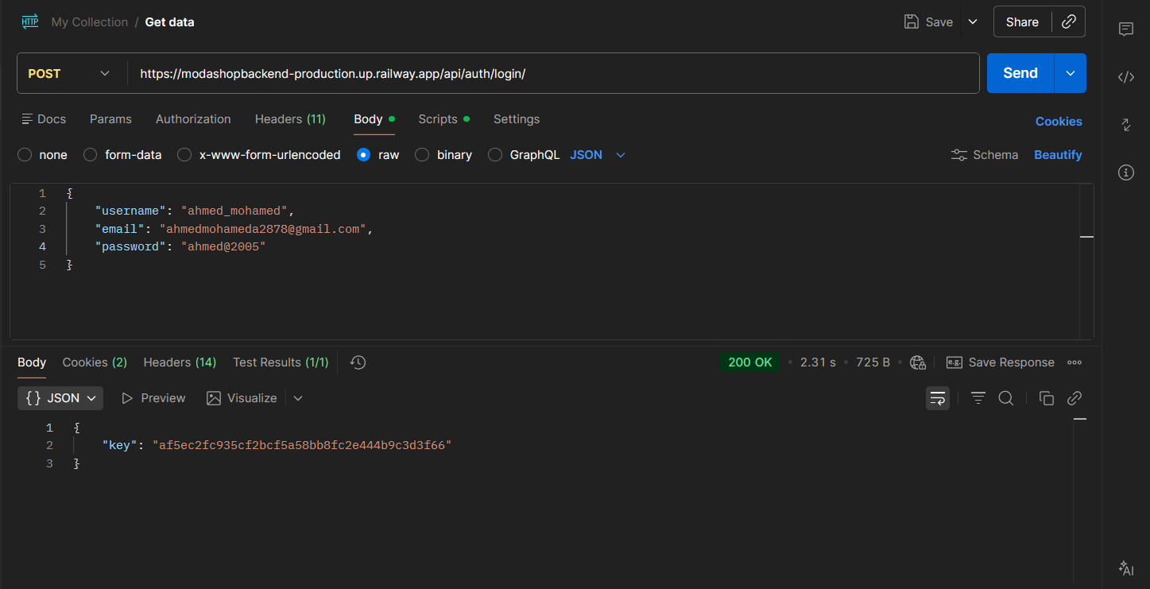

13 – POST/ https://modashopbackend-production.up.railway.app/api/auth/logout/
Logs out an existing user and requires the Authentication Token to be sent
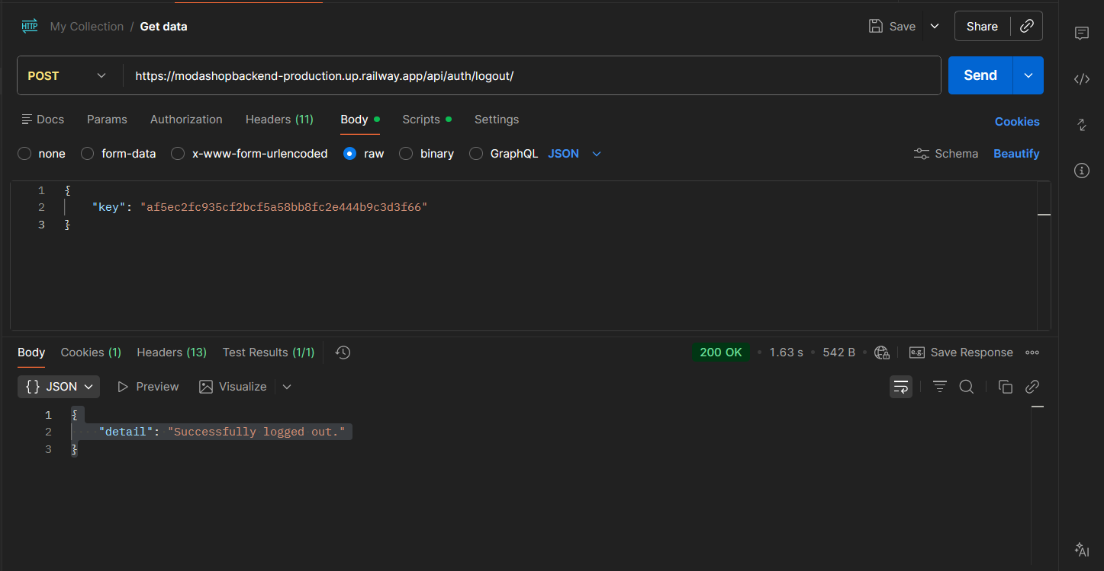

GET/
https://modashopbackend-production.up.railway.app/api/orders/order_details/<order_id>/
Retrives order details with the order id
Requires Authentication
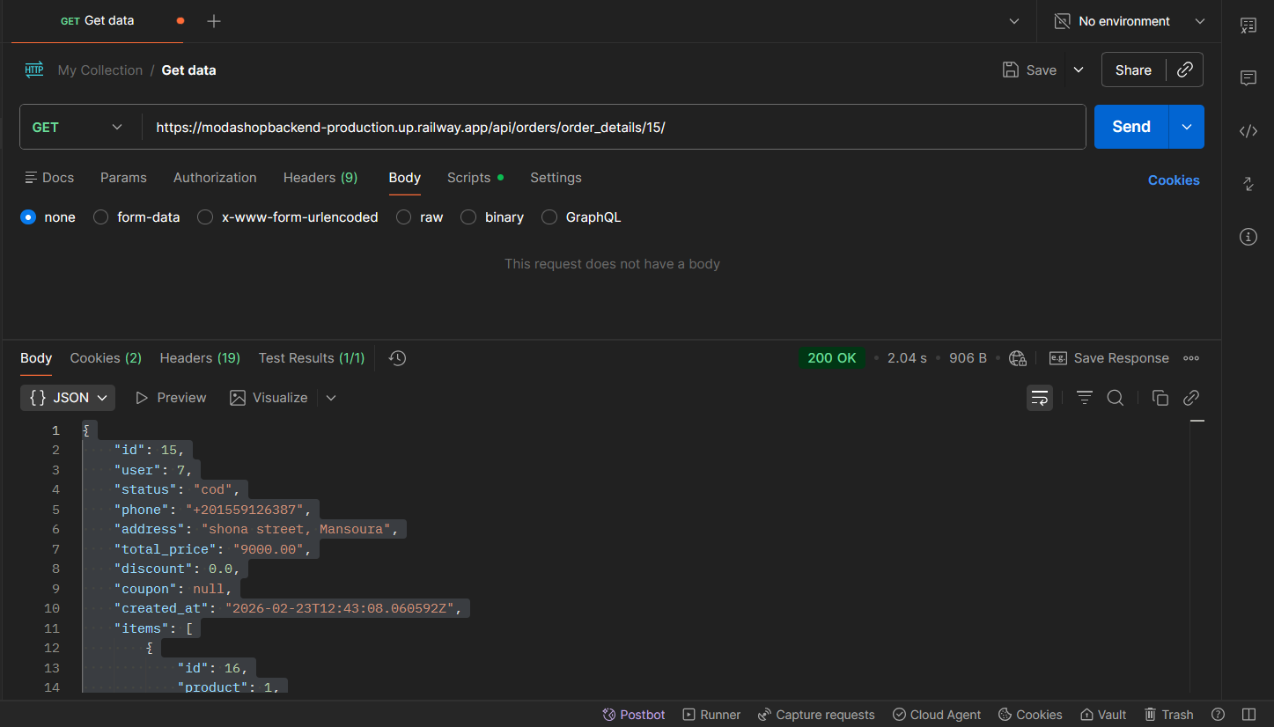
GET/ https://modashopbackend-production.up.railway.app/api/orders/user_orders/
Retrieves all user orders
Requires Authentciation
